**Lab-03**

**Name of Lab:** Creating a Peer-To-Peer Network and Verify the Connectivity

**Theory:**

In a peer-to-peer network, computers on the network are equal, with each workstation providing access to resources and data. This is a simple type of network where computers are able to communicate with one another and share what is on or attached to their computer with other users. It is also one of the easiest types of architectures to create.

**Steps involved in verifying Peer-To-Peer Network**

**Step 1:**

We opened the cisco packet tracer and it looked like figure below which is also the initial phase.



**Step 2:**

Then we added network device in order to establish peer-to-peer network and it look like figure below:

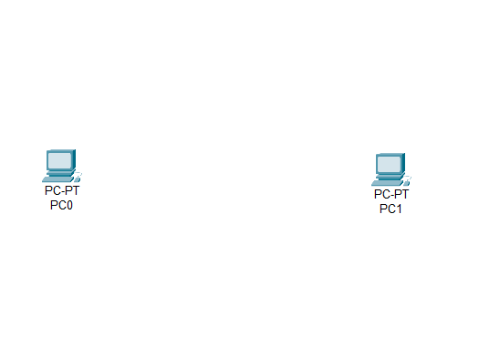

**Step 3:**

Then we connected the devices with each other using cross over wire since we have connected device of same type as figure below:

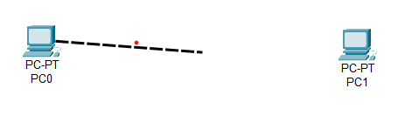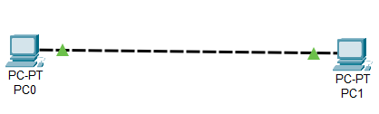

**Step 4:**

In this step we have assigned the both device with internet protocol address(IP) as shown below:

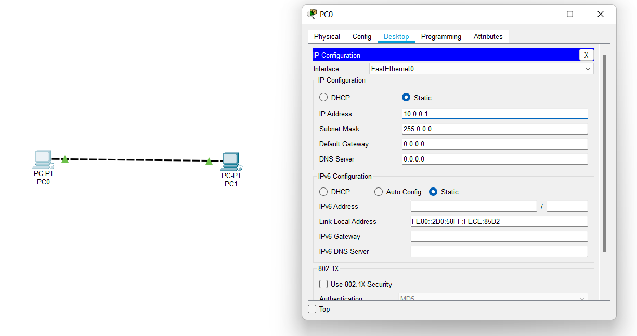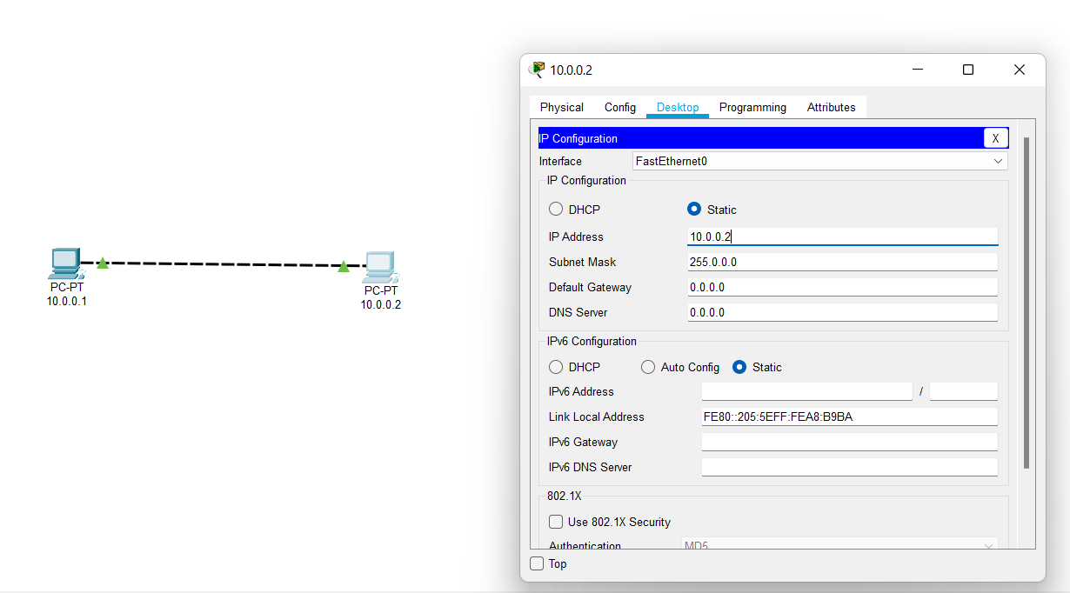

**Step 5:**

In this step we configured both device IP address as shown below:

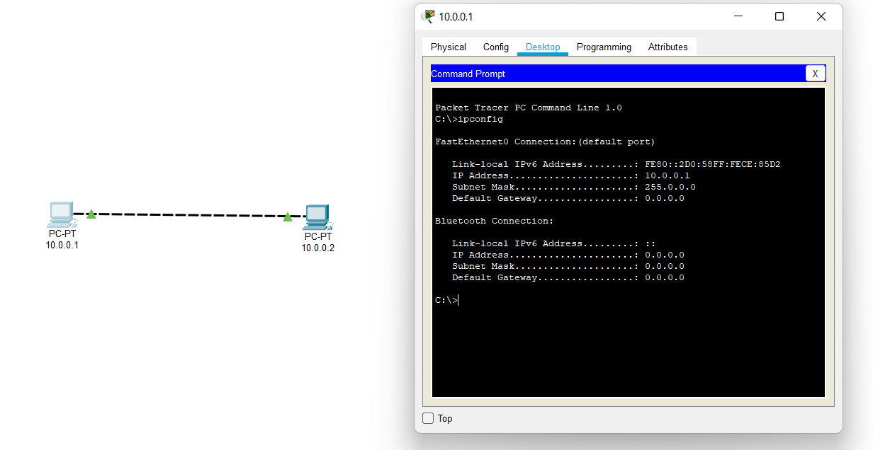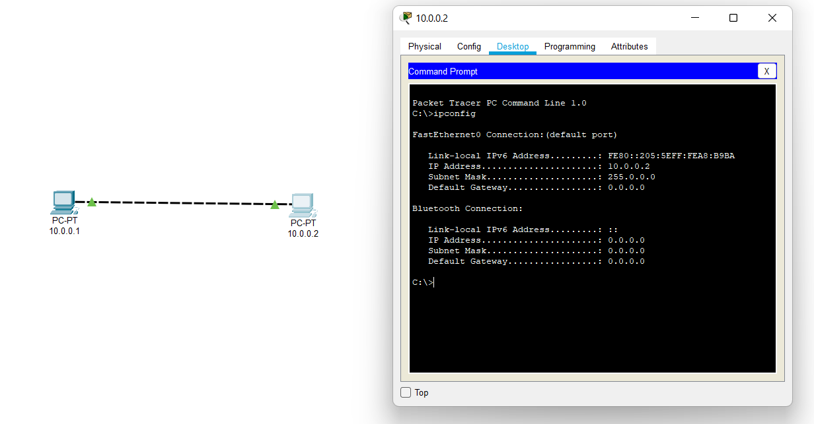

**Step 6:**

Verifying the connection between the networking by ping the device with eachother as shown below:

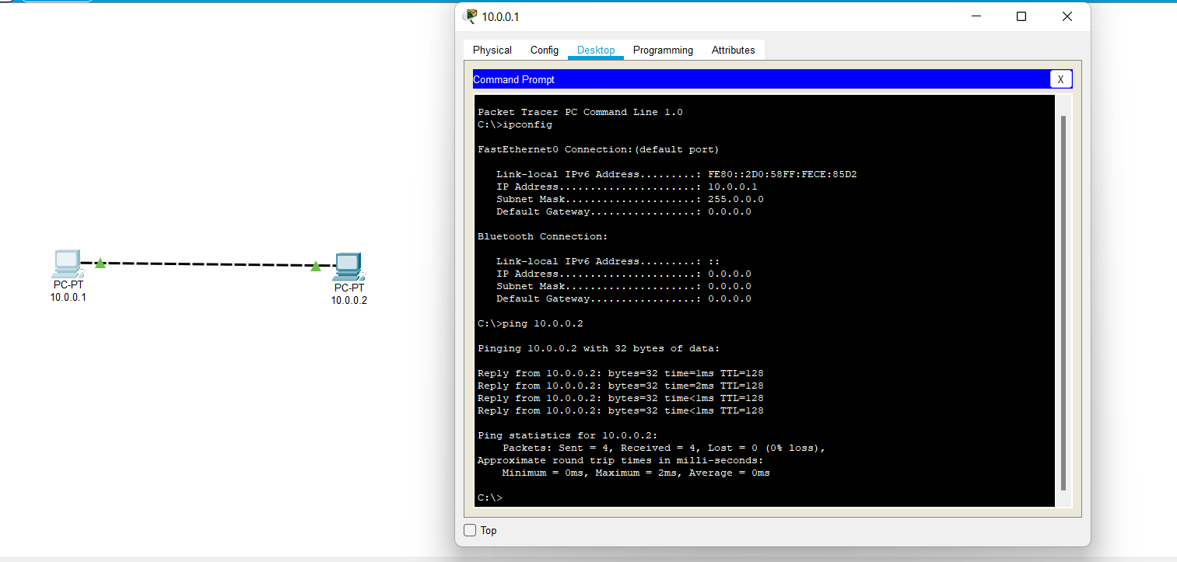

**Step 7:**

Verifying the connectivity by the process of **simulation** and various steps of simulation are shown below:

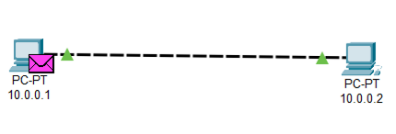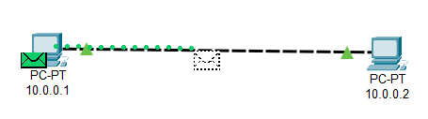 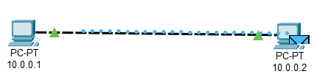 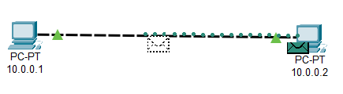

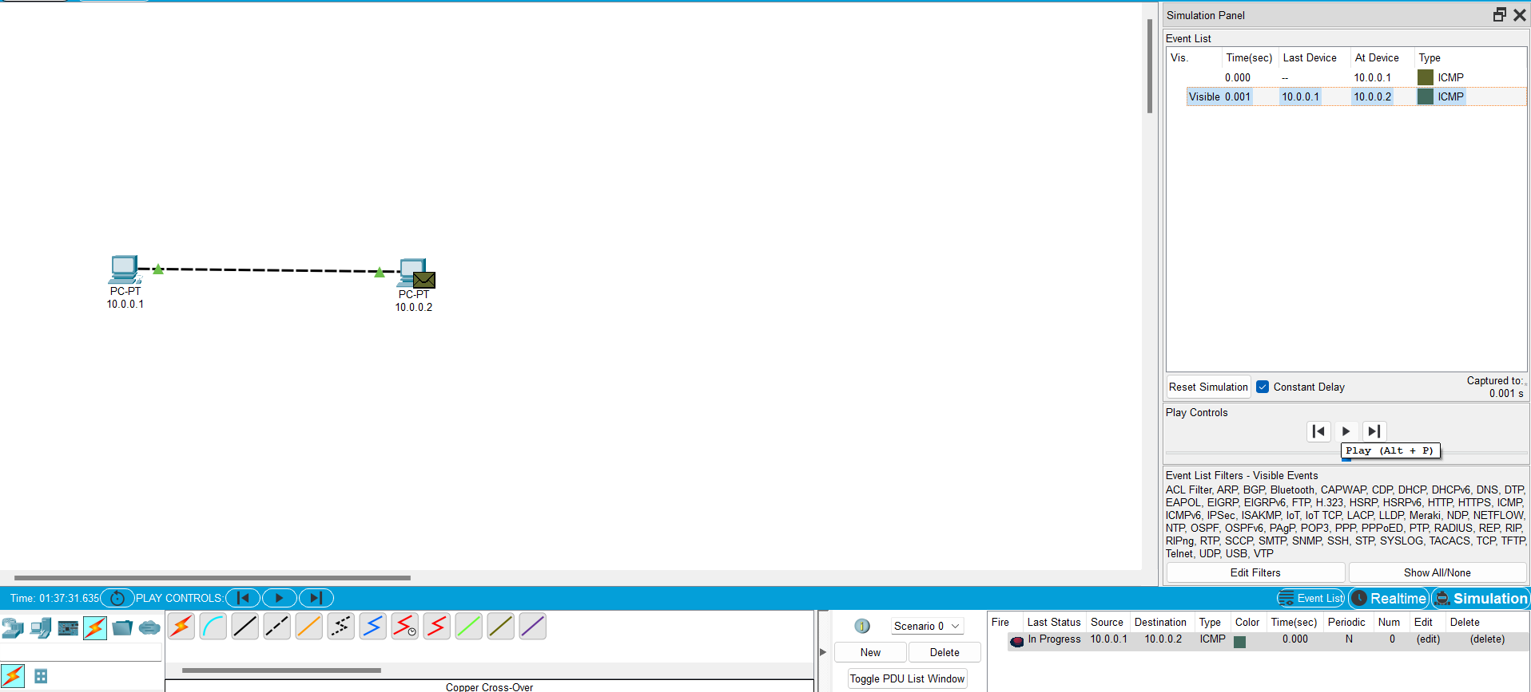

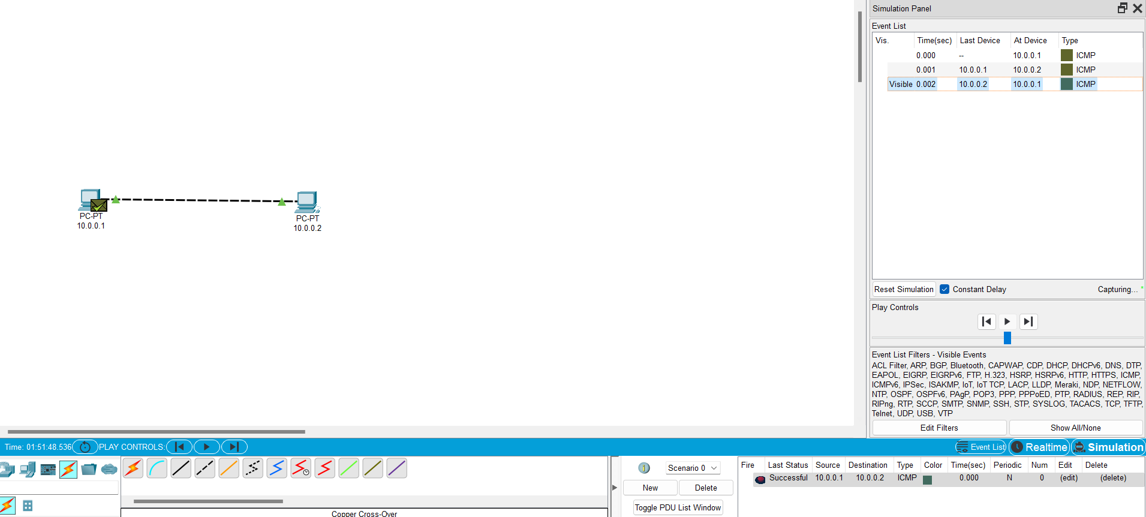

**Conclusion:**

Here in this, lab we came to conclude how peer-to-peer network is constructed and how they communicate with each other with the help of cisco packet tracer.